Information Security

*Project “Venturing cores of ceiser cipher” report*

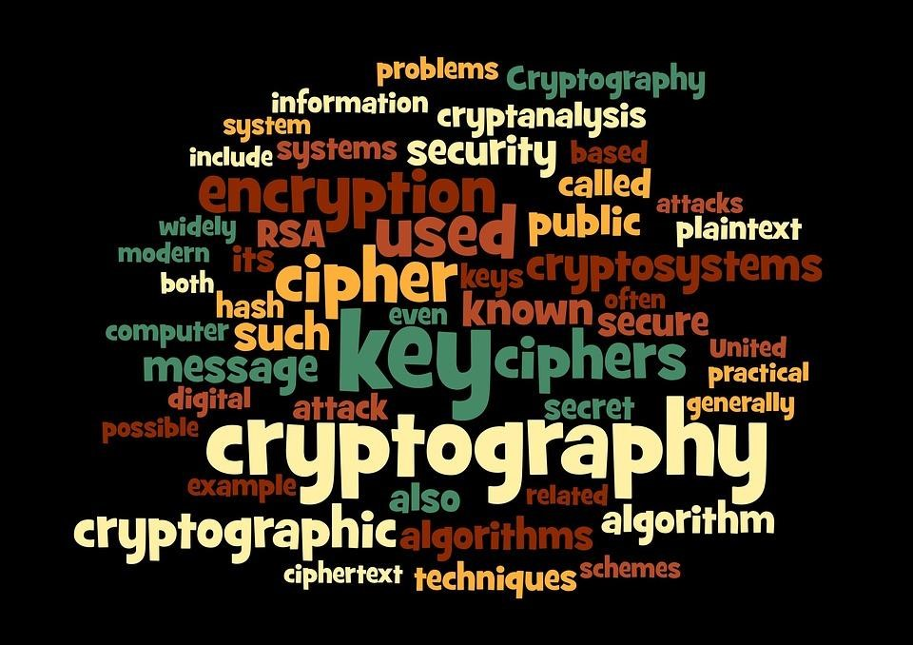

# Group Contributors

19SW42(Lead)

19SW44

19SW45

19SW130

## INTRODUCTION

“Venturing cores of ceiser cipher” project is a practical implication of ceiser cipher which helps the user to encrypt and decrypt secret or confidential information with the help of using.

## Thought Process

By realizing that secrecy in today's world is quite the most overlooked issue, the group decided to dive into venturing a ceiser cipher that enables the users to decrypt and encrypt in need of confidentiality and secrecy. The application can be used by the organization that has a threat of the theft of information.

## Essential parts in Code

1. Ceiser cipher
2. FXMLDocumentController
3. Application
4. Security
5. Hash set
6. Resource bundle

## Specification & features

FXMLDocument is important for the fact that it holds the coding of whole layout designing and outlook, the security is our main class from where everything is being called and the ceiser cipher is critical because it holds all the algorithms used to develop this project.

The application has a textbox accepting text to be encrypted or decrypted as per choice, 3 buttons namely encrypt, decrypt and clear to clear the previous written text.

1

## PROCEDURE

1. A text should be filled in the encryption box.
2. Have to input the key number and you have to make sure that it should be a number, it won’t accept any other entry.
3. Then have to press the encryption button that will encrypt the plain text and would show on the opposite text box.
4. The same text can be decrypted using the same key, as any other key won't successfully decrypt the text.
5. If the user has to encrypt any other code he/she has to clear the previously written code by pressing the clear button below.

## CONCLUSION

The application is instrumental for institutes or organizations that want a secure path to convey the confidential statements or codes. It could be any matter from finance to management and it can be proved vital in such circumstances.